**ECEN 248 - Lab Report**

**Lab Number: 10**

**Lab Title: A Simple Digital Combinational Lock**

**Section Number: 519**

**Student’s Name: Alex Allahar**

**Student’s UIN: 9280098686**

**Date: 11/29/2023**

**TA: Yi Deng**

**Objectives:**

The purpose of this lab was to design a combinational lock which can be opened through the use of a password. This practical circuit will use the previous labs’ skills to describe the lock, and will be tested on the ZYBO Z7-10 board. Finally, this lab will introduce the idea of a Moore machine, a type of Finite State Machine (FSM).

**Design:**

To start this lab, create a new project. Add the combination-lock FSM module design previously into the project. Copy the test bench file of similar name, from the course directory into the simulation sources and simulate the FSM. View the waveform of the simulation. Add the combination_lock design and constraint sources from the course directory into the project, as well as the synchronizer design source module into the project. Fix the combination_lock design source, and set it as the top-level module. Generate Bitstream, and correct any errors until the design builds. Load the design onto the FPGA. Run through the combination sequence shown in the pre lab, and ensure the LEDs glow if given the correct combination. Once the prototype is functional, modify the project to include a fourth number in the password combination. Re-synthesize and implement the design. Retest on the FPGA to ensure that it works properly.

**Conclusion:**

In this lab I was to design a combinational password lock, with a 3 number and 4 number input. I was also able to test the design using the FPGA ZYBO Z7-10 Board.

**Post-lab Deliverables:**

1. **Source Code**

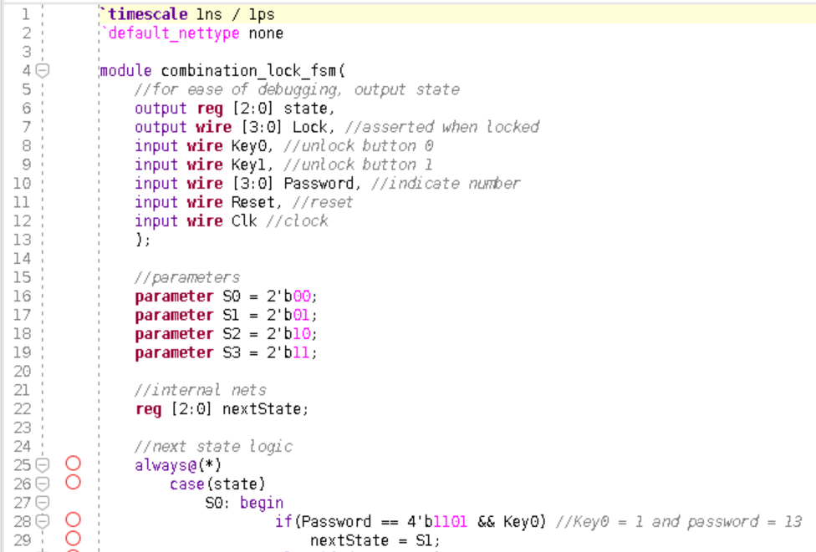

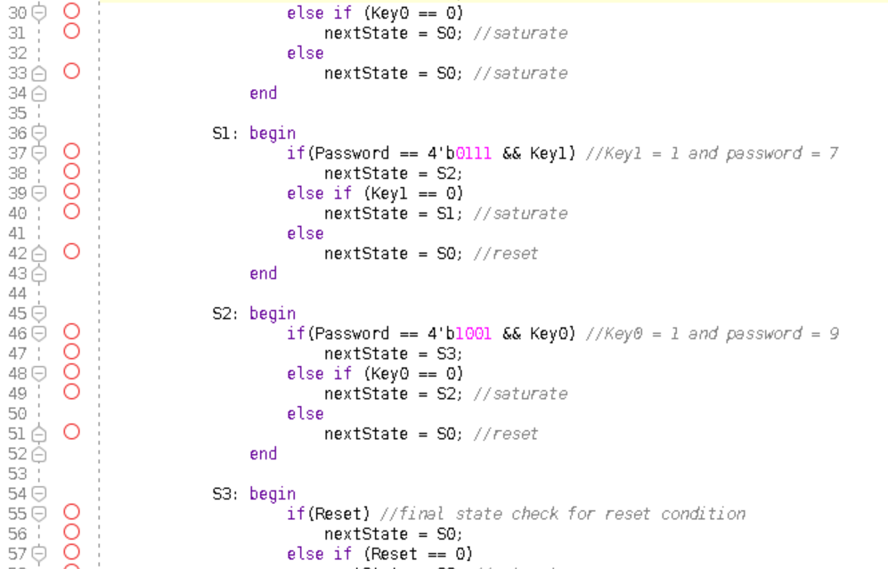

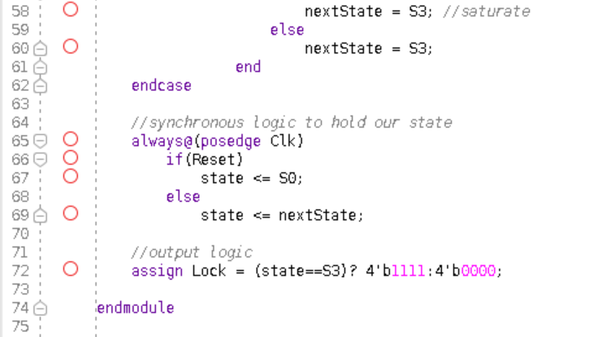

**Figure 1: 3 Number Password Lock Code (FSM.v)**

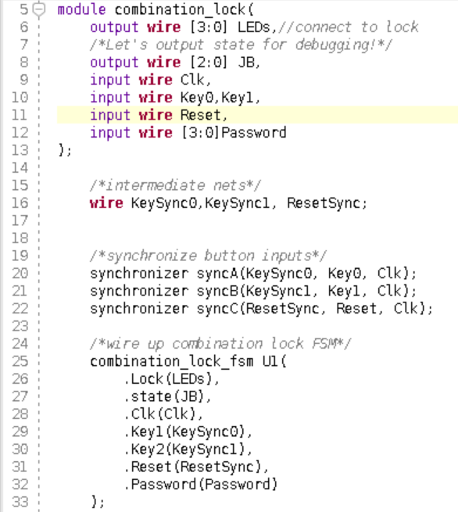

**Figure 2: 3 Number Password Lock Code (comb_lock.v)**

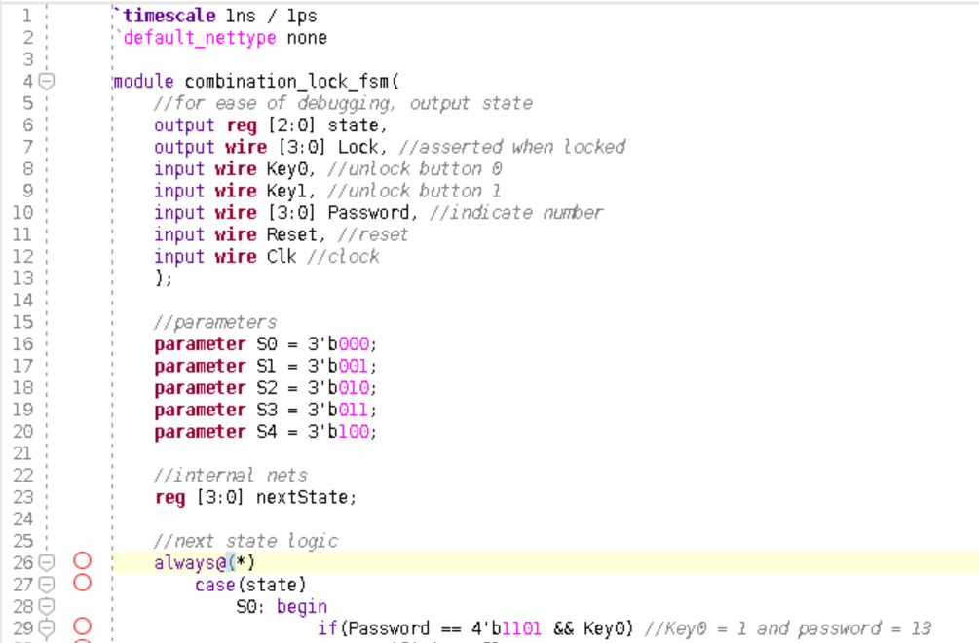

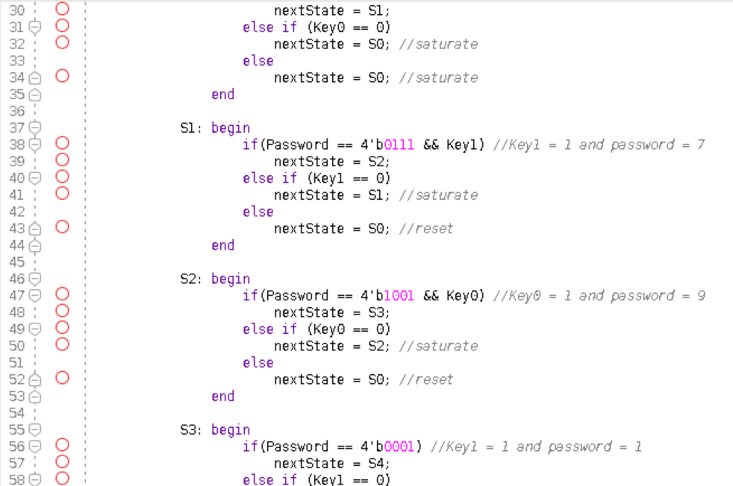

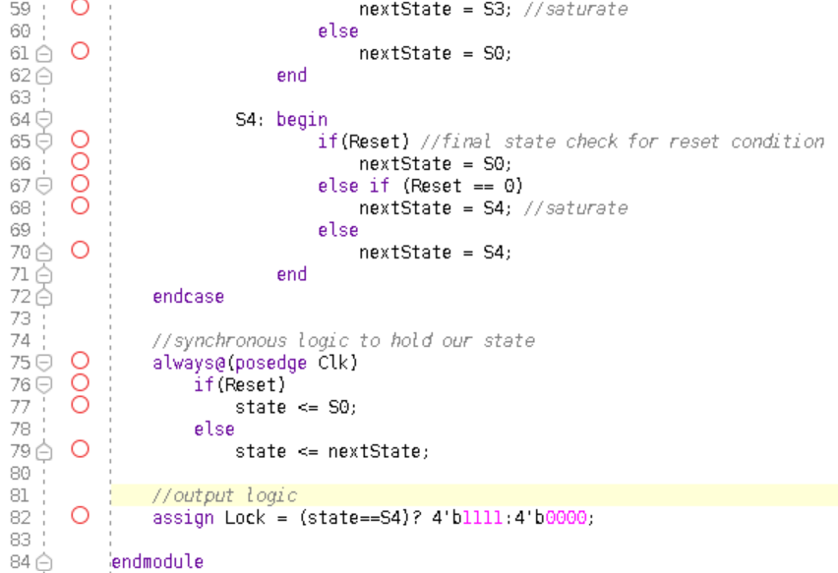

**Figure 3: 4 Number Password Lock Code (FSM.v)**

1. **Waveforms**

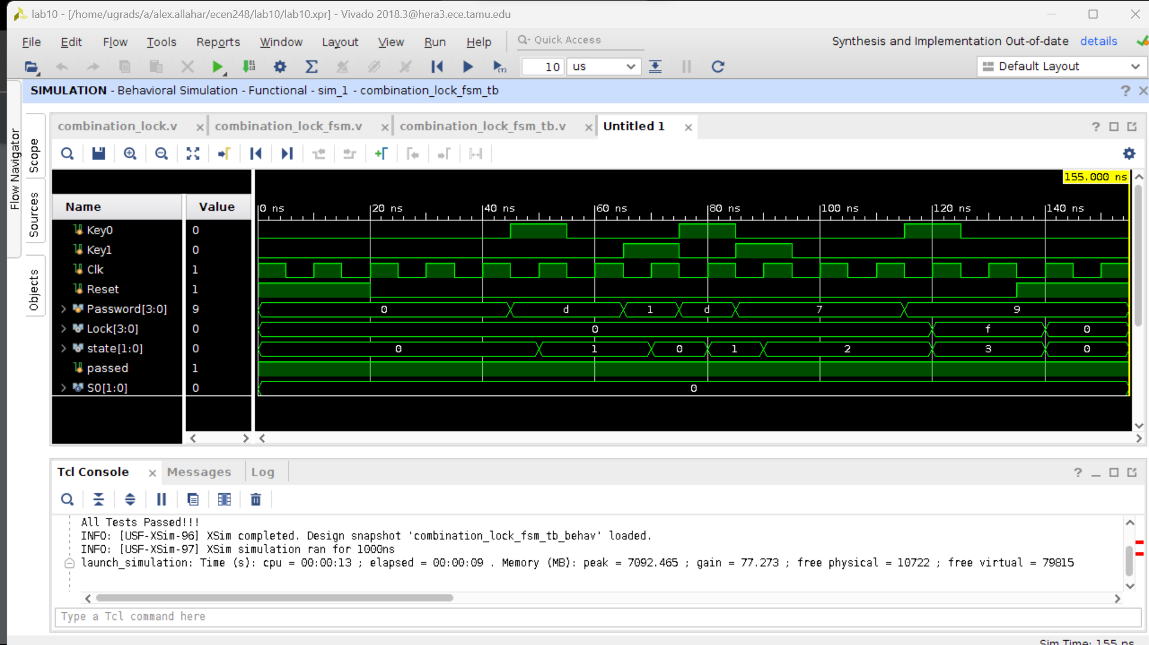

**Figure 4: 3 Number Password waveform**

1. **Questions**

**1, 1e.** No it does not test all cases as it only tests when the password is equal to certain numbers.

1. **A possible attack on your combination-lock is a brute-force attack in which every possible input combination is tried. Given the original design with a combination of three numbers between 0 and 15, how many possible input combinations exist? How about the modified design with a combination of four numbers?**

Because each input has 16 possible options the permutation is 16x16x16= 4096. Adding an extra input number to the password of 16 options increases the possibility of combinations to 65536.